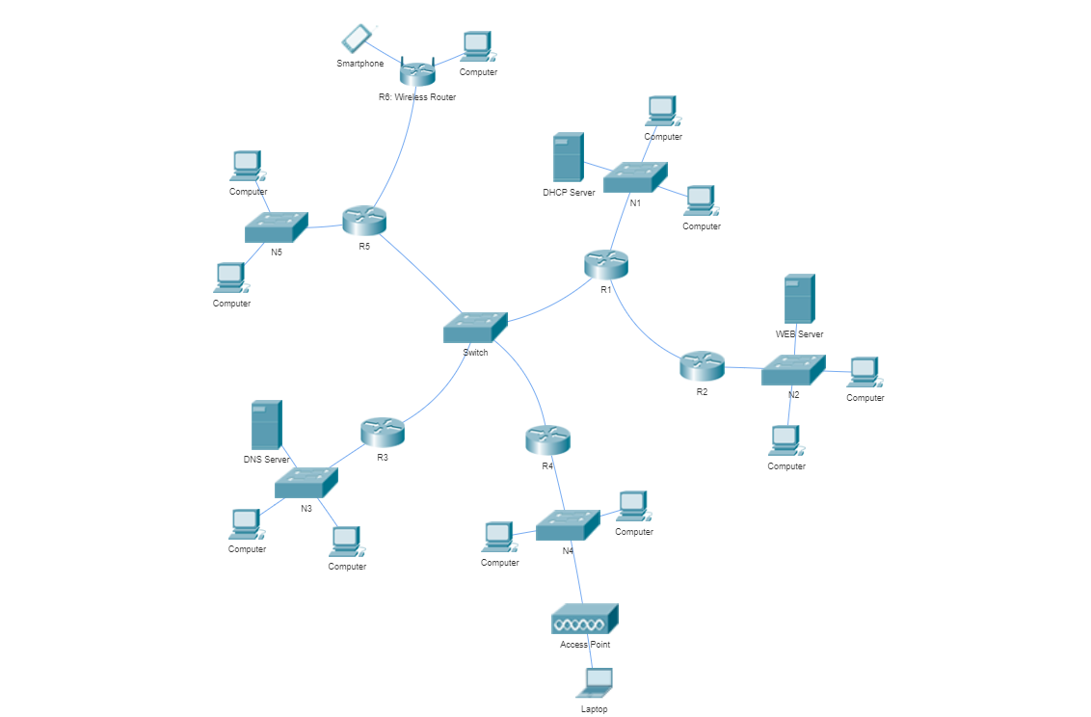

IP: 83.61.156.0, NetMask: 255.255.255.128

Mask: 255.255.255.128 /25 (32-25 = 7 zeros => 2^7)

N1:28

N2:18

N3:8

N4:6

N5:2

N12: 2, N1345: 4, N5w:2

=>N1: 28+3 = 31<32=2^5 /27

N2:18+3 = 21 < 32 = 2^5 /27

N3:8+3 = 11 <16 = 2^4 /28

N4:6+3 = 9 <16 = 2^4 /28

N5:2+3 = 5 <8 = 2^3 /29

N1345: 4+2 = 6 <8 = 2^3 /29

N12: 2+2 = 4 < 4 = 2^2 /30

N5w: 2+2 = 4 < 4 = 2^2 /30

32+32+16+16+8+4+8+4 = 120 < 128 = 2^7

[0-31][32-63][64-79][80-95][96-103][104-111][112-115][116-119][120-127]

n1 n2 n3 n4 n5 n1345 n12 n5w

N1:83.61.156.0 /27 R1=.1, S1=.2, 255.255.255.224 (32-27=5 zeros, 2^5=32, 256-32=224)

N2:83.61.156.32 /27 R2=.33, S2web=.34

N3:83.61.156.64 /28 R3=.65, S3dns=.66 255.255.255.240 (32-28=4 zeros, 2^4=16, 256-16=240)

N4:83.61.156.80 /28 R4=.81

N5:83.61.156.96 /29 R5=.97 255.255.255.248 (32-29=3 zeros, 2^3=8, 256-8=248)

N1345:83.61.156.104 /29 R1=105, R3=106, R4=107, R5=108

N12:83.61.156.112 /30 R1=113, R2=114 255.255.255.252 (32-30=2 zeros, 2^2=4, 256-4=252)

N5w:83.61.156.116/30 R5=117, Rw=118